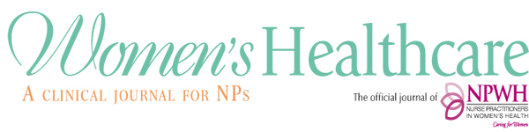
Editorial Advisory Board Application Form
Editorial Advisory Board (EAB) members must be current members of NPWH.
Please review the EAB qualifications, role, and responsibilities.
Please type information and return this application form as an email attachment to Beth Kelsey, Editor-in-Chief, bkelsey@npwomenshealthcare.com.
Include your CV/resume with this application. Be sure that your publication list is up to date.
Name and credentials
Email address
Street address
City, state, zip code
Phone number

Check the advanced practice registered nurse national certification(s) you hold
WHNP
CNM
FNP
AGNP
PMHNP
Other (please list)
What is/are your current practice/academic/research/policy employment setting(s)

What are your clinical/academic/research/policy areas of expertise?

Do you have past experience with editorial involvement with a journal(s)?
If yes, list the journal title, in what capacity you were involved, and years of involvement.

Do you currently have any editorial involvement with another journal(s)? Yes _____ No _____
If yes, list the journal title and in what capacity you are involved.

Do you have experience as a peer reviewer? Yes______ No ______
If yes, list the titles of the journal(s) for which you have provided peer reviews in the past 5 years

What diversity do you believe you can bring to the EAB that would benefit the journal?
Diversity is a broad term encompassing demographic background, identities (innate and selected), collective strength of experiences/beliefs/values/skills/perspectives, and characteristics of the populations you serve.* Please only share what you want, what you believe is relevant to benefiting the journal as an EAB member, and reserve the right to not disclose any aspects of diversity. This information will be kept confidential.

*The definition of diversity is adapted from that of The Coalition for Diversity and Inclusion in Scholarly Communications, https://c4disc.org/principles/
11/2021

