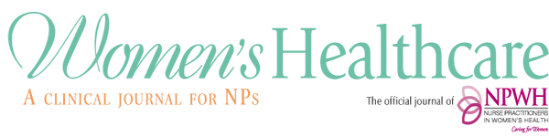
Peer Reviewer Application Form
Peer reviewers must be current members of NPWH.
Peer reviewers may be asked to review up to three manuscripts per year within a 3-week time frame. Information provided on this form is for Women’s Healthcare office use only. It will not be shared with anyone else.
Please type information and return this form as an email attachment to Beth Kelsey, Editor-in-Chief bkelsey@npwh.org. Thank you!
Name and credentials
Email address
Street Address
City, State, Zip Code
Phone Number

Post Baccalaureate Degrees (check all that apply)
Masters |  | DNP |  | PhD |  | Other (please describe)
What is your APRN role and population focus (e.g., WHNP, CNM, FNP)?
What is/are your current practice/academic/employment setting(s)

What are your clinical/academic/research areas of expertise and/or interest?

List articles published in peer-reviewed journals in past 10 years but limit to 5 articles. Provide information in APA or AMA format
Do you have experience as a peer reviewer? Yes______ No ______ *

* You do not have to have published an article or have experience as a peer reviewer. This information however is helpful when assigning manuscripts for review.

6/2020

